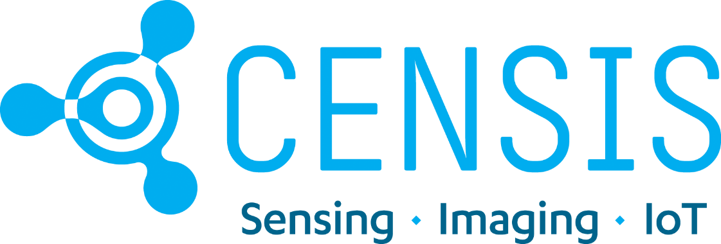

Highlands and Islands IoT Accelerator: Application Form

For full details about the CENSIS Highlands and Islands IoT Accelerator programme, please refer to the CENSIS website https://censis.org.uk/2021/02/12/hie-iot-accelerator-programme/

The Highlands and Islands IoT Accelerator is supported by Highlands and Island Enterprise.

Company Details

Company Name
Trading Address
Postcode
Contact Name |  | Email
Phone |  | Mobile
Company Number |  | Annual Turnover (£)
Website URL |  | Twitter
Nature of Business
Type of company | Sole trader / partnership / limited / not-for-profit / PLC
Nº of employees |  | Trading time to date

Application questions

Q1. Which of these best describes you:
Individual with strong idea and concept, but not trading yet
Early stage company with innovative plans
Mature company looking to change our technology approach
Other (let us know)

Q2. Please describe your IoT-related challenge or idea (max 500 words). If you can, please also provide details of any other challenges you are facing, perhaps around costs, or health and safety regulations.

Q3. What kind of advice or help do you need from CENSIS?

Engineering: hardware
Engineering: software
Engineering: communications/connectivity
Business development
Cyber security advice
Finance and investment advice
IP advice
Contracts or legal advice
Other (please provide details)

Q4. What outcomes to you expect to see in the next three years if you receive support from CENSIS?
New product(s)
New service(s)
Increase in sales (£)
Increase in turnover (£)
Additional investment (£)
Jobs created
Jobs safeguarded
New collaborations
Please use the space below to expand on any of these options or tell us more about any wider social, environmental or economic benefits you expect to see (max. 250 words)?

Q5. Optional: please use this space to add any other information you think will be useful for this application (max 200 words).

Signature:
Name:
Date:
By submitting this application form you are certifying that the information you have provided is true to the best of your knowledge.

Applications can be summited at any time up until 31 May 2021. Please return this form to jim.cockram@censis.org.uk

