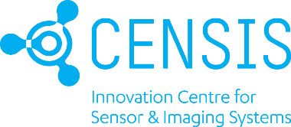

Evaluation of TESTED IoT framework for non-clinical applications: indoor and outdoor assets tracking
Collaborative technology development with CENSIS
for NHS Highland Testbed

The Innovation Section of the Research Development and Innovation Division of NHS Highland has a cluster focus on Internet of Things technologies to address a wide range of issues facing the Health Board in the management of non-clinical processes.

As part of their IoT work, they are working on a multi-partner project funded by the Northern Periphery and Arctic Interreg Programme of the European Union (the other Partners being the University of Ulster and the County of Vasterbotten in Sweden) - TESTED.

The TESTED project focuses on the innovation opportunities offered to healthcare providers and other public bodies by the provision and implementation of an Internet of Things (IoT) infrastructure and strategy.

The project aims to develop a strategic approach to the use of IoT for non-clinical management of issues in health and care systems. Generating a policy and a toolkit for any public body to use and providing documents to support the guidance that will help such organisations and individuals within them, will be the main outputs, along with an IoT solution for asset tracking to solve non-clinical problems

To illustrate how this can all work, the project is supporting an illustrative testbed case which will use the documents and processes from TESTED IoT framework to help the running of the testbed and support the evaluation.

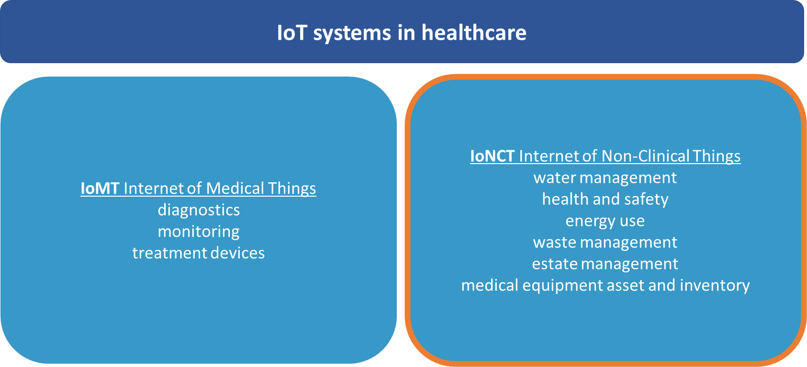
Objectives of the project:
- Test the TESTED IoT framework
- Develop an IoT-based solution for non-clinical asset tracking in collaboration with CENSIS
- Test and adapt the proposed solution to NHS Highland with its specific requirements
- Beyond the testbed - the solution will be tested regarding its scalability and full-system rollout

Benefits for the participating company:
- De-risk tech development - CENSIS will engage in supplying all the necessary R&D works
- Engage with NHS Highland: its procedures and standards
- Open future opportunities for collaboration with healthcare providers
- Co-develop IoT best practice for non-clinical applications
- Co-develop scalability framework for healthcare applications
- Result-dependent, the project can incentivise further procurement efforts from NHS Highland

IoT SOLUTION

Problem
NHS Highland, as the largest land area Health Board in the UK (32,500 km²/12,500 sq mi), faces various challenges across the remote and rural region in which it provides its services.

NHS Highland would like to improve the efficiency and effectiveness of its asset tracking systems by introducing an integrated IoT-based system which should respond to current challenges:
- Eliminate the problem of assets being misplaced due to current system inefficiencies
- Improve the route planning of asset transfers
- Reduce carbon emissions (as a result of the above)

The new system should enable indoor and outdoor tracking of diverse assets, for example, medical equipment, patient samples.

Further requirements of the new system
- Be dashboard / reporting based
- Provide a map base for real time visualisation
- Provide rapid alerts for transporter, and receiving department, to ensure immediate knowledge of location of samples, equipment or other items
- Be accessible through a secure password system (cybersecurity as a priority)
- Be able to respond to requirements in relation to temperature, humidity, maintenance compliance, or other function
- Be compliant with NHS requirements (IG compliant, environmentally sustainable)
- Be compliant with infection control requirements

We are aware that the potential suppliers may not initially meet all requirements. CENSIS will support the development of the missing functions.

Selection criteria
- Previous relevant experience in assets tracking
- The scope of NHS Highland requirements listed above that are covered by a proposed solution
- Compliance with cybersecurity standards
- Delivery / Timescales proposed
- Price

The final decision on the supplier will be made by NHS Highland.

Project timeline
Start – February 2022
Duration – 6 months
Important – The IoT toolkit developed by the TESTED project shall be tested in the first month of the project

It is expected that there will be four scheduled meetings. This includes an initial meeting with partner managers during which the selected supplier and NHS Highland will meet to scope out and discuss final specifications and expectations.

Support available
- Up to 20 days of support with CENSIS: evaluation of the TESTED IoT framework and technology development
- Reimbursement for reasonable material costs to the company following the agreement of the pilot project with NHS Highland and CENSIS

Register Your Interest. Submit the application form to natalia.lukaszewicz@censis.org.uk & stephen.milne@censis.org.uk. Application deadline – 5pm, 17th January 2022.

Pre-selected companies will be invited to an interview (online) with NHS Highland and CENSIS. The selection process is led by NHS Highland.

