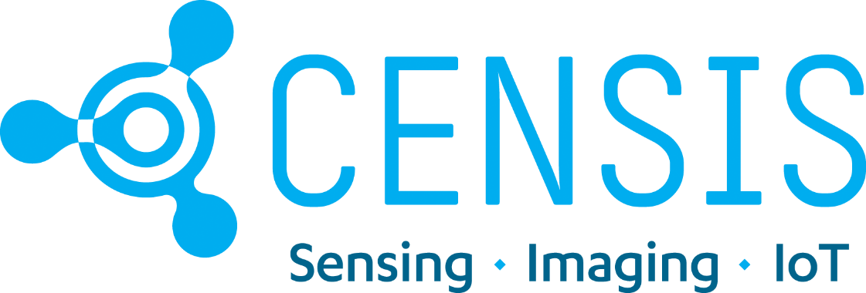

Highlands and Islands IoT Enhanced Accelerator: Application Form

For full details about the CENSIS Highlands and Islands Enhanced IoT Accelerator programme, please refer to the CENSIS website LINK HERE

The Highlands and Islands IoT Enhanced Accelerator is supported by Highlands and Island Enterprise.

Company Details

Company Name
Trading Address
Postcode
Contact Name
Phone
Company Number
Website URL
Nature of Business
Type of company
Nº of employees

Application questions

Q1. Which of these best describes you:
Individual with strong idea and concept, but not trading yet
Early-stage company with innovative plans
Mature company looking to change our technology approach
Other (let us know)

Q2. Please describe the business challenge you face (max 500 words). If you can, please also provide details of any other challenges that might be related that you are facing, perhaps around costs, business process/es, net-zero, or health and safety regulations.
Q3. Please describe how you think an IoT system might help you solve your challenge or idea (max 500 words). How you might see the system being integrated into your daily business processes to help either People/Process/Product/Planet or all 4.
The trail monitoring will allow us to clearly understand how the trails are being used and by how many people. This will allow us to streamline and focus our maintenance. It will also

Q4. What kind of advice or help do you need from CENSIS?

Engineering: hardware
Engineering: software
Engineering: communications/connectivity
Business development
Cyber security advice
Finance and investment advice
IP advice
Contracts or legal advice
Other (please provide details)

Q5. What outcomes to you expect to see in the next three years if you receive support from CENSIS and were able to implement your IoT system?
New product(s)
New service(s)
Increase in sales (£)
Increase in turnover (£)
Additional investment (£)
Jobs created
Jobs safeguarded
New collaborations
Carbon Reduction (operational/embedded/product use)
Please use the space below to expand on any of these options or tell us more about any wider social, environmental, or economic benefits you expect to see (max. 250 words)?

Q6. Optional: please use this space to add any other information you think will be useful for this application (max 200 words).

Signature:
Name:
Date:

By submitting this application form you are certifying that the information you have provided is true to the best of your knowledge.

Applications can be summited at any time up until 31 May 2023. Please return this form to jim.cockram@censis.org.uk

